Michael Johnson

COMP 3710

Assignment 3

Use Case

* As a user, I would like to enter a note on the application and have that note saved to the screen.

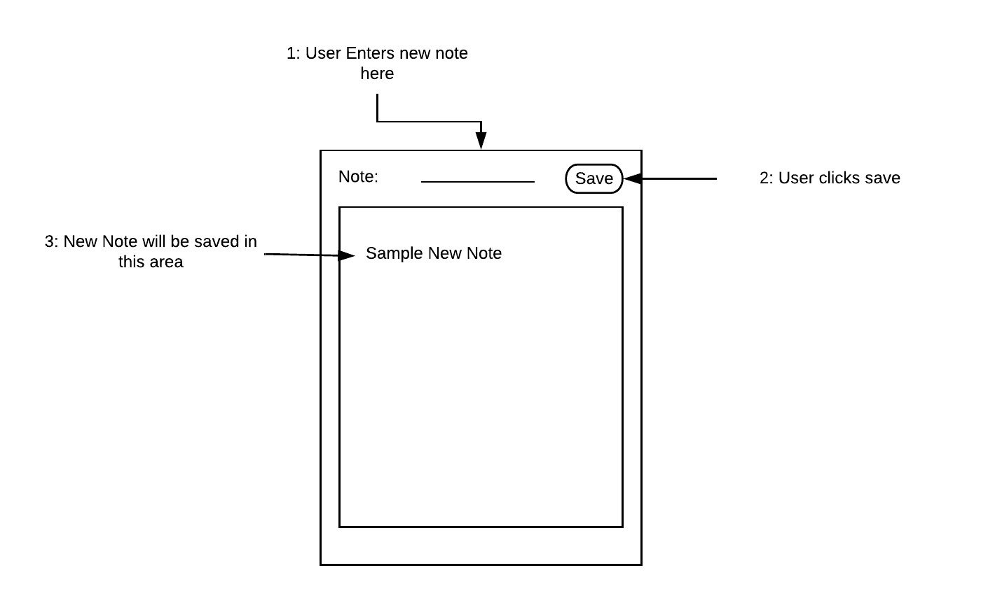

* As a user, I would like to edit a note that has been saved to the screen.

